Shabbos Stories for
Parshas tazria-metzora 5781
Volume 13, Issue 33 5 Iyar/April 17, 2021
Printed L’illuy nishmas Nechama bas R’ Noach, a”h

For a free subscription, please forward your request to keren18@juno.com
Past stories can be found on the website ShabbosStories.com
The Midnight Mystery
And the Halted Plague
By Elchonon Isaacs

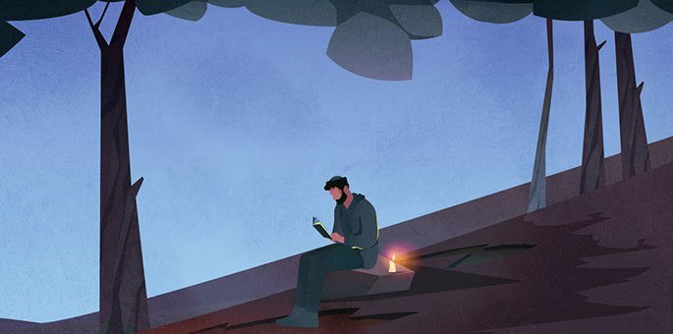

During the years when Rabbi Shmuel Eliezer Eidels (1555–1631, known as the Maharsha) was the rabbi of Ostroh, a deadly plague broke out. The rabbi and the venerable members of the beit din instructed that a day be dedicated to prayer, fasting, introspection and repentance. The rabbi also announced that if anyone knew of issues in the community that needed to be rectified, they should discreetly notify him.
One of the townsfolk lived on the fringes of society and was never seen at the communal prayers. Up to this point, not much attention was paid to this fact, but after the rabbi's request to share any information that could remedy the situation, two townspeople decided to investigate the man and track his whereabouts.
After a few days, they noticed that every night he left his house at midnight and headed to the forest outside the city. They followed him discreetly until he left the town behind, but when he disappeared into the thick forest, they lost him. Minds racing, the duo imagined that he must be up to some nefarious activities, perhaps even part of a band of thieves.

Much to Their Surprise
The next day they shared their findings with the rabbi, as well as their suspicions. Much to their surprise, the rabbi said, “Tonight I will join you, and we will follow him together.”
The scene repeated itself. At midnight the man left his house and began walking quietly towards the forest. Urged on by the rabbi, the small group followed him until he came to a clearing. There he stopped, sat down on a rock, and lit a candle. He then took out a small prayer book and began reciting Tikkun Chatzot, the traditional dirges lamenting the destruction of the Holy Temple, with great fervor.
The three men stood open-mouthed, listening to his prayer. Suddenly he broke out in tears that melted their hearts. But there was something else that struck them; they seemed to hear a second voice reciting the prayer with him.
“This fellow is certainly not a highway robber,” murmured the rabbi. “But who is the second voice that we are hearing?”
When he exited the forest, the three men approached the man. Apologizing for the surprise encounter, the rabbi explained: “Your conduct piqued the curiosity of some members of the community, so we had to track you. Now we ascertained that our fears were unfounded. But please explain who the second voice that we heard with you was?”

Out of Respect for the Rabbi
The man was perplexed by the question, but out of respect for the rabbi, he answered: “It has been my custom for some time now to mourn the destruction of the Holy Temple, and it seems that my prayers caused great satisfaction on high. Jeremiah, the prophet who foresaw and experienced the destruction, joins me on a nightly basis.”
The three of them looked at him in amazement. The rabbi broke the silence and asked: "If you have such a merit, why don't you inquire in heaven as to the reason for the plague in our city? Additionally, why is it that you never join the community in prayer?”
"Tomorrow, I will come to the morning prayer and answer both questions together," the man replied and headed home.
The next morning in the main synagogue, the rabbi watched the door, awaiting the arrival of the hidden saint whom he met the previous night. The prayers began on time, but the man did not show. About halfway through, the man entered while wrapped in his tallit and tefillin.

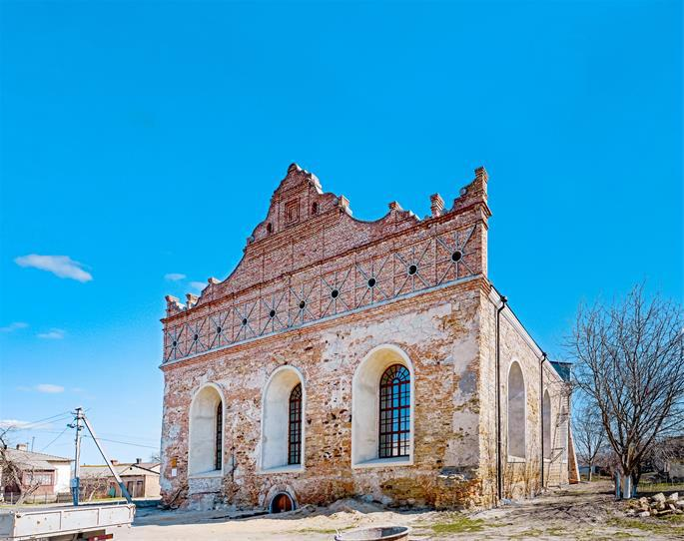
The synagogue of the Maharsha, as it can be seen today, in Ostroh (photo:wiki).
Suddenly there was a commotion in the crowd, and an incomprehensible fear fell on those present. Worshippers who tried to look at him were filled with anxiety and had to take their eyes off him, and some of them even went outside the synagogue to calm down. All the while, the man stood in the corner and prayed devoutly, clearly oblivious to the commotion he was causing.
When the prayers concluded, the man removed and folded his tallit and tefillin. The rabbi approached him and said: "Now I have a third question, what caused the fear when you entered?"

A Reference to the Tefillin
The man explained: "The Torah states: ‘Then all the peoples of the earth will see that the name of the L-rd is called upon you, and they will fear you’ (Deuteronomy 28:10). And our sages note: This refers to the tefillin that are on the head. Thus tefillin causes fear, and that is why fear gripped those who saw me wearing my tefillin.”
"But I also wear tefillin daily," countered the rabbi. “Why is no one awestruck by me?”
"It is because I am careful not to speak anything mundane while the tefillin are on me. I respect the tefillin properly; therefore, their sanctity is preserved. You all fulfill your obligation to wear tefillin, but because you are frivolous, the sanctity of the tefillin is compromised."
The rabbi listened, as did the others. Then the man added: “This is why I do not come to the synagogue, because the masses are not meticulous in respecting the synagogue's sanctity. I do not want to be tempted to speak while in the synagogue, especially when I wear tefillin.”

A Remedy to Stop the Epidemic
After a moment of silence, the man continued. "In my opinion, if this problem will be remedied, the epidemic will stop."
The story quickly spread and all residents agreed to strengthen their commitment to upholding the sanctity of the synagogue and tefillin, and in a few days, the plague stopped.
The residents of Ostroh continued to keep their commitment even after the plague ended and life returned to normal. The synagogue became known as the Maharsha’s shul, after the rabbi, and it was treated with the utmost sanctity.

Reprinted from the Parshat Shemini 5781 email of Chabad.Org Magazine.

Rav of Komemiyus – Rabbi Binyomin Mendelson: Part 1

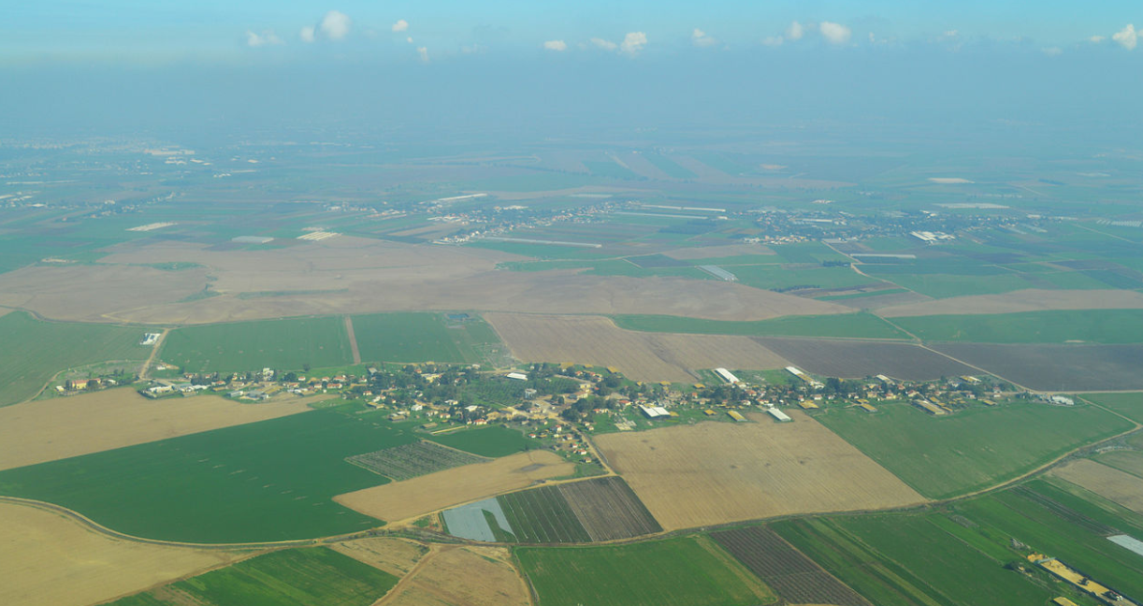
Aerial view of Moshav Komemiyus

His entire life and every action was dedicated to Hashem’s Will; and from that stemmed all of his spiritual greatness. It is difficult to imagine how R’ Binyomin Mendelson achieved greatness in so many capacities – as a Gaon in halacha, a Torah teacher, a Poseik, a Rav and leader of a community, one who deeply loved his fellow Jew, a strong fighter for Hashem’s Will, and many more sterling achievements.

A Beloved Rav
This beloved Rav, who was renowned as the Rav of Moshav Komemiyus, was as distant from our earthly standards as heaven is from earth. Yet he was closely attuned to his people’s needs. A warm and caring chassid, he lived on this planet, but his mind and heart existed in a heavenly realm.
A man of absolute truth, his strong leadership and strict adherence to every halacha fortified Moshav Komemiyus and many other settlements to strictly adhere to the laws of shemittah and other laws of the land of Eretz Yisroel, at a time when it was not prevalent. In his fifty years as Rav, he drew many people closer to Torah and mitzvos.

Following in the Footsteps of a Distinguished Ancestor
R’ Binyomin was born in Plotzk, Poland. He followed in the footsteps of his ancestor, R’ Moshe of Zolshin, author of Mishpat Tzedek on Tehillim, who constantly strove to instill fear of Heaven in the hearts of his followers. R’ Binyomin received his early education from his father, the tzaddik R’ Menachem Mendel, a great Gaon in Torah who would devote every possible minute to learning Torah.
When he would change from one sefer to the next, he would close his eyes and whisper to himself, “I have set Hashem before me always.” R’ Menachem Mendel also taught others, serving as Rosh Mesivta in Plotzk for ten years. He never derived any benefit from this world. He was so highly regarded that many people came to him to ask that he pray for the ill and those needing salvation.
R’ Binyomin’s mother was very righteous, devoting her life to allowing her great husband to learn Torah for its own sake. Their youngest son, R’ Binyomin, was raised in this pure home. At an early age, his father instilled in him the importance of holiness and purity in one’s actions and thoughts, which is a segulah to understanding one’s Torah study and to acquiring fear of Heaven.
Aside from young Binyomin’s outstanding mental abilities, he excelled in his remarkable desire to learn Torah – and he exerted himself to acquire every morsel of Torah, like a thirsty man who cannot seem to quench his thirst. As a young bachur, he had already mastered the halachic seforim of the Noda B’Yehudah and Avnei Nezer, the Talmud Bavli and Shulchan Aruch, the seforim of the Sfas Emes and Yismach Yisroel, and more.

Always Sitting and Studying Diligently
R’ Binyomin was a permanent fixture in the Plotzk Beis Medrash – always sitting and studying diligently, day and night. It was unheard of in Plotzk for one to enter the Beis Medrash and not see Binyomin learning there.
Once someone brought a radio to Plotzk. Being that it was a new invention, everyone ran to marvel at this wonder. Everyone except Binyomin. A friend asked why he was not interested in seeing the radio. “Of course I am interested. But I am far more interested in the words of the Gemara…”
While learning in the Yeshivah in Plotzk, R’ Binyomin once fell ill and was forced to remain in bed for an extended period of time. He utilized his time by thoroughly learning the seforim of the Ramchal (R’ Moshe Chaim Luzzato), which strengthened his faith in Hashem. He was later to draw on this to strengthen the faith of many of his friends and to strengthen himself to face the secular winds which threatened the foundations of Torah in Eretz Yisroel.
When he later settled in Eretz Yisroel, R’ Binyomin would often travel to Teveryah and pray at the grave of the Ramchal to express his appreciation for the immense spiritual gains he derived from the Ramchal’s seforim.

Years of Spiritual Growth
The years R’ Binyomin spent learning in Plotzk after the First World War were years of spiritual growth and preparation for the holy tasks and difficult challenges he would face in his life. After his marriage to the daughter of R’ Aharon Moshe Chaimowitz, a Gerrer chassid, R’ Binyomin settled in his wife’s hometown where he opened and led a yeshivah for ten years. It was a highly organized yeshivah. R’ Binyomin’s great abilities in teaching and understanding Torah were revealed as he guided each student to reach his potential.
The surviving students of the Plotzk Yeshivah always spoke of that golden period of their lives, when they merited to hear the innovative Torah thoughts of R’ Binyomin, from a holy mouth that was fully steeped in fear of Heaven. His Torah remained alive within them even throughout the horrors of the Holocaust.
R’ Binyomin conducted his life in a holy manner. He was a devoted chassid of Ger, who was bound heart and soul to the Imrei Emes, R’ Avrohom Mordechai of Ger. R’ Binyomin was of the few who was capable of recording the deep Torah thoughts of the Imrei Emes. He remained close to the succeeding Rebbes of Ger – the Beis Yisroel, the Lev Simcha – until his final day.

A Prominent Rav and Talmid Chochom
Though he was a prominent Rav and talmid chochom, and Rebbi of many talmidim, R’ Binyomin subjugated himself to his holy Rebbes as a modest chassid among many other chassidim. Upon the advice of his Rebbe, the Imrei Emes, R’ Binyomin ascended from Poland to Eretz Yisroel in 1933 to fulfill the mitzvah of settling in the holy land.
So deep was his love for Eretz Yisroel that he was willing to move there no matter what the cost, and if he would not find a position as Rav or Rosh Yeshivah, he was ready to become a simple storekeeper. His motivation was purely for the sake of Heaven, as was all he did throughout his life.
Before he left, he was offered the prestigious position as Rav of Sanok in Galicia. But his heart was drawn to Eretz Yisroel, and he declined the offer. R’ Binyomin became the Rav of Kfar Attah (now Kiryat Attah) in Haifa. He was a Rav who busied himself with his task at hand and shunned Rabbinical honors. His only guiding light was the Will of Hashem.
With love and endless sacrifices, R’ Binyomin built up and cared for his community. The people loved and respected him; his word was law. His personal schedule was one of discipline and devotion. He spent hours praying with deep fervor and emotion. He learned Torah day and night with great diligence, teaching others both privately and publicly, and recording his Torah thoughts.

Praised by the Satmar Rebbe
The Torah giants of the time recognized R’ Binyomin’s greatness and loftiness. The holy R’ Aharon of Belz said that R’ Binyomin was a Rav on the caliber of the Rabbonim who lived 200 years ago. The Satmar Rebbe, R’ Yoel Teitelbaum, said that R’ Binyomin was living proof that one can properly carry out his responsibilities as Rav in Eretz Yisroel.
The Chazon Ish wrote of R’ Binyomin that “all of his deeds are for the sake of Heaven,” and that he is a “complete tzaddik.” The Brisker Rav said of R’ Binyomin, “His ‘wealth’ is fear of Hashem.”
The light of R’ Binyomin’s Torah greatness shone forth from Kfar Attah to all of Eretz Yisroel. People from far and wide came to him for psak halachah and to conduct Dinei Torah. Many of the most difficult questions and cases were brought to R’ Binyomin. At times R’ Binyomin was asked to serve on other Batei Dinim with the most outstanding Torah giants of the time. But he was not only a poseik. He was not only a Rav.
He was a complete and consummate leader of his people. He cared for every aspect of his community’s needs. When the remnants of the Holocaust reached Eretz Yisroel, R’ Binyomin distinguished himself in becoming like a father to the orphans and a husband to the widows. He exerted himself to help young refugees find shidduchim and establish homes as they had no relatives to assist them. So devotedly did he extend himself on their behalf, that one would think he was closely related to all of these destitute refugees!

Acting Solely for the Honor of Hashem
His strong stance in upholding Torah and halacha as a Rav never diminished his humility, for he acted solely for the honor of Hashem. He once admonished the owner of a bakery about his negligence in certain areas of kashrus. Right afterwards, R’ Binyomin was heard loudly berating himself, “If I myself had not sinned, I would not be forced to admonish my fellow Jew…”
He was never seen preparing to give a public drosha, save for his spiritual preparations. He was heard to whisper to himself right before his drosha, “Hashem, please put the right words in my mouth so that I may reach the ears of those listening…” (Marbitzei Torah Me’Olam HaChassidus, Vol. 8) The yahrzeit of R’ Binyomin ben R’ Menachem Mendel Mendelson zt”l is on 24 Iyar (1979). May his merit protect us.

Reprinted from the Parshas Shemini 5781 email of The Weekly Vort.
True Happiness

Reb Avrohom Dovid Tennenhaus of Montreal was originally a Viznitzer chossid and had become a full-fledged Lubavitcher. He merited a unique relationship with the [Lubavitcher] Rebbe, in which he dared ask what others would not.
He once asked the Rebbe a question that was bothering him, “How is it that Marilyn Monroe, a goyishe actress, earns five million dollars a year, while our mashpia Reb Peretz Motchkin wears a tattered sirtuk [frock coat or Chassidic kapote]. In fact, before he enters yechidus, he borrows the sirtuk of Reb Yerachmiel Binyominson… “Where is the justice?”
Reb Avrohom Dovid continued, “Does the posuk not state, ‘The silver is Mine, and the gold is Mine, says Hashem (Chagai 2:8)?’”
The Rebbe responded, “I doubt Reb Peretz is fully aware of how ripped his sirtuk is. And if he is, it bothers him in ‘his left foot.’ He is truly a happy person. “Whereas this woman, lehavdil, is actually deeply depressed. Despite her great wealth, she has no happiness. In fact,” the Rebbe concluded, “it will soon be apparent…”
A few weeks later, this woman, who was in her thirties, committed suicide. (Tevel Berachvei Hachassidim Otzar)

Reprinted from the Pesach 5781 edition of The Weekly Farbrenen.

The Melamud’s “Curse”?

Reb Efraim Waxman Shlita, Rosh Yeshivas Me'or Yitzchak, told me that when he was a child learning in cheder, one of his melamdim was a holocaust survivor. When the children were acting up and misbehaving, he would mumble something under his breath.
The children could sometimes make out a few of the words that he said. They didn't know the meaning of the words, but they were sure that he was cursing them in Hungarian.
At the end of the year, the children asked their melamed forgiveness for causing him so much distress over the year, until he cursed them. The melamed replied, "Chas v'shalom! I never cursed you. I was saying These. etc קנכרי טרקיא פנטרי, words are Onkelus's סמקן ירקן וברקן, to translation the precious gems of the choshen, which the kohen gadol wore."
The melamed explained, "The gems on the choshen represent the Jewish nation, and it teaches that they are precious gems before Hashem. To control my anger, I reminded myself.

Reprinted from the Parshas Shemini 5781 email of Torah Wellsprings

Travelling with Eliyahu HaNavi (Elijah the Prophet)
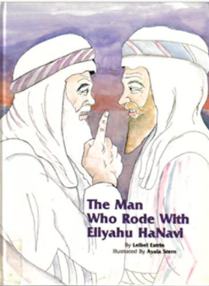

Reb Nissim Gaon relates the following Midrash: Once, Reb Yehoshua ben Levi asked Eliyahu HaNavi to come along with him on his travels. Eliyahu HaNavi told Reb Yehoshua ben Levi that he can come along on one condition: Reb Yehoshua ben Levi cannot ask any questions.
Reb Yehoshua ben Levi agreed, and they set out on their travels. At their first stopover, they knocked at the home of an elderly couple and said, "We are travelers, and we need a place to stay."
The couple graciously took them in, performed hachnasas orchim superbly, gave them whatever they requested, and honored them immensely. Before leaving this home, Reb Yehoshua ben Levi heard Eliyahu HaNavi daven, "Please, Hashem, let their cow die…"
Reb Yehoshua ben Levi was shocked. The cow was the elderly couple's source of parnassah. Why did Eliyahu HaNavi punish them after they treated them so well? But he didn't ask any questions, as he promised that he wouldn't.

The Home of a Very Stingy Person
Later, at nighttime, they knocked at the home of a very stingy person, and they asked him if they can stay in his home. At first, the miser didn't let them in, but Eliyahu HaNavi pleaded with him, and he grudgingly allowed them in his home but refused to give them any food. In the morning, Reb Yehoshua ben Levi heard Eliyahu HaNavi daven, "Hashem, please, the wall that surrounds this house should be strong and firm. Don't let it collapse…"
"Why was Eliyahu HaNavi praying for this miser?" Reb Yehoshua ben Levi wondered. "He didn't give us food and didn't even want us to sleep in his home!" But he didn't ask Eliyahu for an explanation, as he had promised. They traveled on, and they arrived at a very unfriendly city. The residents pretended not to see them, and no one invited them into their homes. Reb Yehoshua ben Levi heard Eliyahu daven and say, "May everyone in this city become a leader." Once again, Reb Yehoshua ben Levi didn't understand but kept silent.
They traveled on and arrived at a very kind city. Everyone invited wanted to host them. Reb Yehoshua ben Levi thought, "If for the inhospitable people, Eliyahu blessed each of them to become a leader, he will certainly give a special brachah to this fine town. But Reb Yehoshua ben Levi heard Eliyahu HaNavi say in his tefillos, "May only one person of this city become a leader."

Yehoshua is Completely Confounded
Reb Yehoshua ben Levi informed Eliyahu HaNavi that he no longer wants to travel with him because he couldn't understand anything at all. But now that they weren't traveling together anymore, Reb Yehoshua ben Levi had the right to ask the questions that were bothering him all along and asked Eliyahu HaNavi to explain.
Eliyahu Hanavi replied, "Our first stop was at the home of the elderly couple who honored us immensely and served us a fine meal. I thought, 'What can I give them?' The woman of this home was destined to die shortly after we leave, so I davened that their cow should die instead of her.
"Then we came to the home of a miser. He just barely allowed us in his house, and he didn't give us a morsel to eat. He deserves to be punished for the way he treated us. The miser doesn't know about it, but there's a treasure buried in the ground, under the wall surrounding his home. The people who lived in his house, before him, buried the treasure there. As time passes, it is natural that the wall will collapse, and then the miser would find the treasure and become wealthy. I prayed that the wall should be solid and firm, and it shouldn't fall in his lifetime. He doesn't deserve it.
"Then we arrived at the inhospitable city. No one even said shalom aleichem to us, and no one invited us to their home, and I gave them what they deserve. I prayed that each of them should become a leader. This isn't good for them because it is better when there is only one leader. When there are many heads, there are machlokes constantly. No one will want to live in that city. "As for the hospitable city, I blessed them with one leader, which is indeed a blessing."

Reprinted from the Parshas Shemini 5781 email of Torah Wellsprings

Kashrus and Chalav
Yisroel (Jewish) Milk

The Chasam Sofer once asked two community activists to set up a meeting with the mayor of Pressburg. "The issue is urgent, so schedule the meeting immediately."
The delegates asked the mayor's secretary to schedule a meeting for that very day, but the secretary replied, "All slots are filled for today. You can't get an appointment on such short notice. If you want, we can schedule it for next week…" The delegates explained to the secretary that the matter was urgent, and it couldn't be postponed. It wasn't easy, but with their determination and efforts, a meeting with the mayor was arranged for that very day.
They entered the mayor's room, and the mayor graciously offered them a cup of coffee. "No, thank you," they replied.
"Why not?" the mayor asked. "Is it because it isn't kosher?"
That was the reason. The milk wasn't chalav Yisrael [milk from a cow under Jewish supervision].
The mayor went into a rage. "If I offer you a drink, you should accept it!" he said. As he was ranting and raving, the secretary opened the door and asked the mayor whether he had a cup of coffee.
"No. The mayor replied angrily. "I was about to, but these fellows ruined my appetite. I offered them a coffee, but they declined… because of kashrus."
"Good," the secretary replied. "I'm glad you didn't have a coffee because the milk is contaminated. Some people who drank from this milk got sick, and the doctor checked the milk and determined that it is unhealthy.

The mayor immediately changed his tone of speech, and he spoke with the two delegates respectfully. He told them, "I always admired the rabbis of the Jewish nation for their superior wisdom. I forgot about that, of late, and I was considering banishing all the Jews from Pressburg. But now that you reminded me of the wisdom of the Jewish sages, and I will cancel that decree."
The two delegates returned to the Chasam Sofer and told him what happened at the meeting. The Chasam Sofer replied that there was a kitrug in heaven on the Jewish community because they weren't careful enough with kashrus and with חלב .ם"עכו [avoiding milk of the goyim].
In the merit of the delegate's mesirus nefesh to keep the laws of kashrus, the decree was abolished. (Heard from Reb Elchanan Halperin zt'l of Radumishla, who heard it from his father-inlaw, Reb Shmuel Unsdorfer zt'l, a descendant of the Chasam Sofer.)

Reprinted from the Parshas Shemini 5781 email of Torah Wellsprings

A Grandfather’s Defining Moment of Truth

There is a story in Rabbi Nachman’s book Incredible! about a man named Joe Wallis. Joe was on his way home from work when he stopped by The Elephant Steakhouse, an unkosher restaurant in Tel Aviv, to get take-out for his wife and children. He could hear the sizzle of grilling meat and frying onions. He looked up at the pictures of food displayed above the counter, “Pork in pita,” he thought. “The kids are going to love it.”
He waited on the line to place his order, and as he stood surrounded by laughing people, he began to daydream. The steakhouse slowly faded away while a story he heard when he was a young child popped into Joe’s head. It was a story about his mother’s father, Rav Winkler.

The Grandfather’s Backkbreaking Work
When the Nazi came to Hungary and took the family away, his grandfather was sent to a labor camp instead of Auschwitz. The Rav was condemned to backbreaking work, terrible abuse, and starvation. Although almost everyone around him ate whatever they could lay their malnourished hands on, Joe’s grandfather never defiled his mouth with non-kosher food.
Time passed, and the inmates were gathered in a circle when the SS officer in charge began to speak. “Germany has lost the war,” he said. “The Russians will be here momentarily. You are about to become free men again. You will be reunited with your wives and children if they’re still alive. But before you leave, before we unlock the gates, we have one final test. We’ve heard your Rabbiner Winkler is a man of principle. We need to find out just how strong-willed he is.” The Nazi grabbed Rav Winkler and maneuvered him forcibly to the center of the circle.

Challenged to Take Just One Bite of Pork
“Rabbiner,” the Nazi addressed his prisoner, “You want to go home like everybody else, don’t you?” The Nazi motioned to one of the officers, who walked over carrying a plate with a solitary piece of pork. “Rabbiner, the moment you take a bite of this pork, you’ll be freed. You’ll walk through the gates and go home. Otherwise you will be killed in this camp. The choice is yours. One bite is all it takes.” No one breathed as they waited. One bite of pork suddenly equaled life. What would the Rav do? “I will not eat this pork,” he said. The German shot Joe’s grandfather, and he crumpled to the ground, the final Jew to perish at that camp.
Joe came back to himself. “What on earth am I doing here, waiting to purchase meat my grandfather would rather die than eat? And I’m feeding this food to my wife and children when I have the means to buy any type of food?” Joe stood in the middle of that busy, cheerful, unkosher restaurant, unaware of anything but the incredible argument taking place within him. On that humid summer evening, something changed in his heart, and Joe Wallis walked out of The Elephant Steakhouse with empty hands.

Touching and Transforming the Lives of Many Jews
Joe, now Rabbi Yossi Wallis, became CEO of Arachim, the ultra-successful global kiruv organization. Rabbi Wallis has touched and transformed the lives of tens of thousands of Jews and has developed personal, warm relationships with many of our greatest Torah leaders, all because of an unexpected discovery of his Torah heritage while waiting in a restaurant for his unkosher sandwich.
May we all realize that Hashem truly runs the world and learn from Aharon to immediately accept Hashem’s Will with joy. May we also strive to keep the kashrut laws as it is written in our holy Torah, because those laws elevate us both in body and soul. May we see the arrival of Mashiah speedily in our days! Amen!
Reprinted from the Parshat Shemini 5781 email of Rabbi Amram Sananes as written by Jack E. Rahmey.

